**Login page**

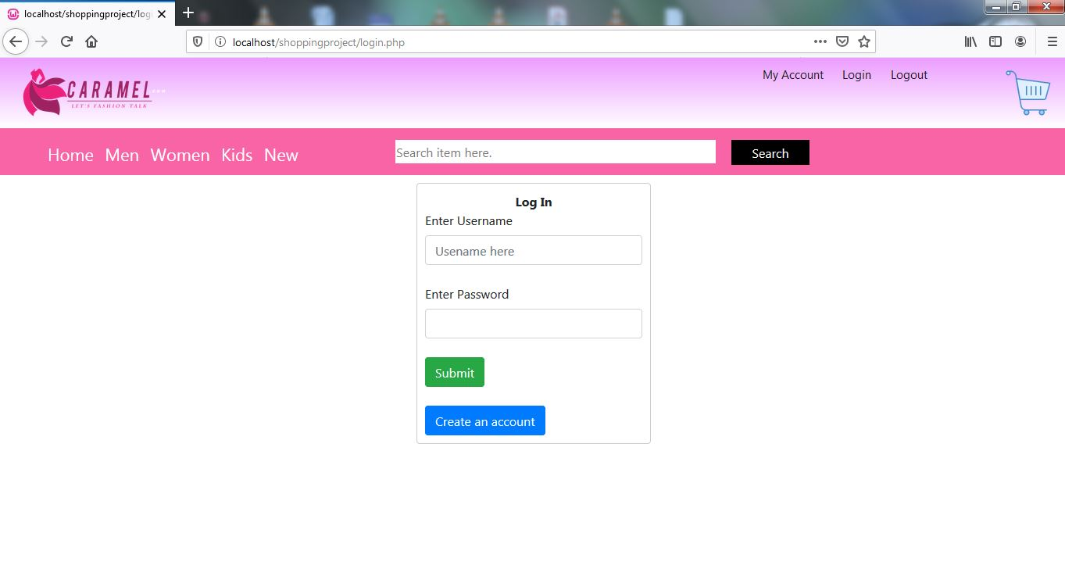

<?php

$servername = "localhost";

$dbname = "shopping";

$username = "root";

$password = "";

$conn = mysqli_connect($servername,$username,$password,$dbname);

if($conn)

{

echo "";

}

else

{

die("Connection faild because ".mysqli_connect_error());

}

?>

<?php

error_reporting(0);

ob_start();

include("codes\DbConnect\dbconnect.php");

?>

<!DOCTYPE html>

<html>

<head>

<title>CARAMEL</title>

<meta name="viewport" content="width=device-width, initial-scale=1.0">

<link rel="stylesheet" type="text/css" href="codes/css/header.css">

<link rel="stylesheet" type="text/css" href="codes/css/slider.css">

<link rel="stylesheet" type="text/css" href="codes/css/footer.css">

<link rel="stylesheet" type="text/css" href="codes/css/saler-body.css">

<!-- Global styles START -->

<script type="text/javascript" src="..\shoppingproject\codes\java script\jquery-3.4.0.min.js"></script>

<script src="https://maxcdn.bootstrapcdn.com/bootstrap/4.0.0/js/bootstrap.min.js" integrity="sha384-JZR6Spejh4U02d8jOt6vLEHfe/JQGiRRSQQxSfFWpi1MquVdAyjUar5+76PVCmYl" crossorigin="anonymous"></script>

<link rel="stylesheet" href="https://maxcdn.bootstrapcdn.com/bootstrap/4.0.0/css/bootstrap.min.css" integrity="sha384-Gn5384xqQ1aoWXA+058RXPxPg6fy4IWvTNh0E263XmFcJlSAwiGgFAW/dAiS6JXm" crossorigin="anonymous">

</head>

<body>

<!-- ----------------Header------------------ -->

<div class="header">

<div class="logo-bar">

<img src="logo/FINAL -1.PNG">

<div id="cart">

<a href="cart.php"><img src="logo/cart.PNG"></a>

</div>

</div>

<?php

session_start();

if($session==true){

header('location:index.php');

echo "<style>

p #login-text{display: none;}

p #logout-text{display: block;}

</style>";

}

?>

<div class="upper-links">

<a href="#"><p>My Account</p></a>

<a href="login.php"><p id="login-text">Login</p> </a>

<a href="logout.php" style="" ><p id="logout-text">Logout</p> </a>

</div>

<div class="navbar">

<ul>

<a href="index.php">

<li>Home</li>

</a>

<a href="product.php">

<li>Men</li>

</a>

<a href="product.php">

<li>Women</li>

</a>

<a href="product.php">

<li>Kids</li>

</a>

<a href="product.php">

<li>New</li>

</a>

</ul>

<input type="text" name="search" placeholder="Search item here." id="search-bar">

<a href=""><BUTTON>Search</BUTTON></a>

</div>

</div>

</body>

</html>

<?php

error_reporting();

ob_start();

?>

<!DOCTYPE html>

<html>

<head>

<title></title>

<link rel="stylesheet" href="https://maxcdn.bootstrapcdn.com/bootstrap/4.0.0/css/bootstrap.min.css" integrity="sha384-Gn5384xqQ1aoWXA+058RXPxPg6fy4IWvTNh0E263XmFcJlSAwiGgFAW/dAiS6JXm" crossorigin="anonymous">

<style type="text/css">

body{

margin: 0;

padding: 0;

}

.form-box{

background: white;

width: 300px;

height: auto;

position: absolute;

left: 50%;

top: 50%;

transform: translate(-50%, -50%);

border: 1px solid #ccc;

padding: 10px;

border-radius: 4px;

}

.header-details{

position: absolute;

left: 50%;

transform: translateX(-50%);

padding-top: 0px;

font-weight: bold;

}

</style>

</head>

<body>

<?php

include 'header.php';

?>

<div class="form-box">

<form method="post" action="login.php">

<label class="header-details">Log In</label><br>

<label for="exampleInputEmail1">Enter Username</label>

<input type="text" class="form-control" name="uid" placeholder="Usename here" required autofocus><br>

<label for="exampleInputEmail1">Enter Password</label>

<input type="Password" class="form-control" id="exampleInputEmail1" aria-describedby="emailHelp" name="pwd"><br>

<input type="submit" name="loger" value="Submit" class="btn btn-success">

</form><br>

<button onclick="location.href='create_account.php'" class="btn btn-primary">Create an account</button>

</div>

<?php

if(isset($_POST['loger']))

{

$uid = $_POST['uid'];

$pwd = $_POST['pwd'];

$result = mysqli_query($conn, "SELECT * FROM users WHERE u_name='$uid' AND u_pass='$pwd'");

if($row = mysqli_fetch_array($result))

{

$name= $row['username'];

$_SESSION['uname']=$row['u_name'];//stores userid session

$_SESSION['upass']=$row['u_pass'];//stores password session

$_SESSION['user']=$name;

$session=$_SESSION['user'];

header('location: index.php');

}

else

{

echo '<script type="text/javascript">alert("Invalid Username or Password!");</script>';

}

}

?>

</body>

</html>

**Create account page**

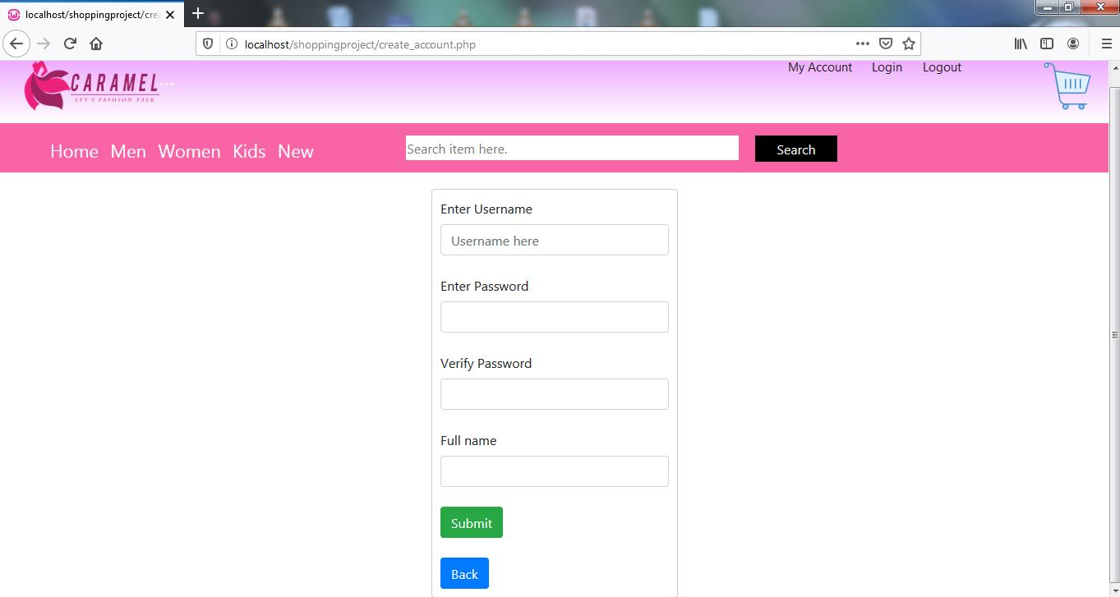

<?php

ob_start();

?>

<!DOCTYPE html>

<html>

<head>

<title></title>

<link rel="stylesheet" href="https://maxcdn.bootstrapcdn.com/bootstrap/4.0.0/css/bootstrap.min.css" integrity="sha384-Gn5384xqQ1aoWXA+058RXPxPg6fy4IWvTNh0E263XmFcJlSAwiGgFAW/dAiS6JXm" crossorigin="anonymous">

<style type="text/css">

body{

margin: 0;

padding: 0;

}

.form-box{

background: white;

width: 300px;

height: auto;

position: relative;

left: 50%;

margin-top: 20px;

transform: translateX(-50%);

border: 1px solid #ccc;

padding: 10px;

border-radius: 4px;

}

.header-details{

position: absolute;

left: 50%;

transform: translateX(-50%);

padding-top: 0px;

font-weight: bold;

}

</style>

</head>

<body>

<?php

include 'header.php';

?>

<div class="form-box">

<form method="post" action="">

<label for="">Enter Username</label>

<input type="text" class="form-control" id="exampleInputEmail1" placeholder="Username here" name="uid" required autofocus><br>

<label for="exampleInputEmail">Enter Password</label>

<input type="Password" class="form-control" id="exampleInputPass" name="pwd"><br>

<label for="exampleInputEmail">Verify Password</label>

<input type="Password" class="form-control" id="exampleInputVPass" name="vwd"><br>

<label for="">Full name</label>

<input type="text" class="form-control" id="exampleInputEmail1" name="name"><br>

<input type="submit" name="loger" value="Submit" class="btn btn-success">

</form><br>

<button onclick="location.href='login.php'" class="btn btn-primary">Back</button>

</div>

<?php

if(isset($_POST['loger']))

{

$sql = "SELECT * FROM users";

$result=mysqli_query($conn,$sql);

$row = mysqli_fetch_array($result,MYSQLI_ASSOC);

$user= $row['u_name'];

$uid = mysqli_real_escape_string($conn, $_POST['uid']);

$pwd = mysqli_real_escape_string($conn, $_POST['pwd']);

$vwd = mysqli_real_escape_string($conn, $_POST['vwd']);

$nm = mysqli_real_escape_string($conn, $_POST['name']);

if(!empty($uid) && !empty($pwd) && !empty($vwd) && !empty($nm)){

if($pwd==$vwd){

if($uid!=$user){

$sql2= "INSERT INTO users (u_name, u_pass, username) VALUES ('$uid', '$pwd', '$nm')";

if(mysqli_query($conn,$sql2))

{

echo "<script> alert('Success'); </script>";

header('location:login.php');

}

}else{echo "<script> alert('Already taken Username.'); </script>";}

}else{ echo "<script> alert('Password did not mached.'); </script>"; }

}

else{

echo "<script> alert('All fields are required.'); </script>";

}

}

?>

</body>

</html>

**Home page**

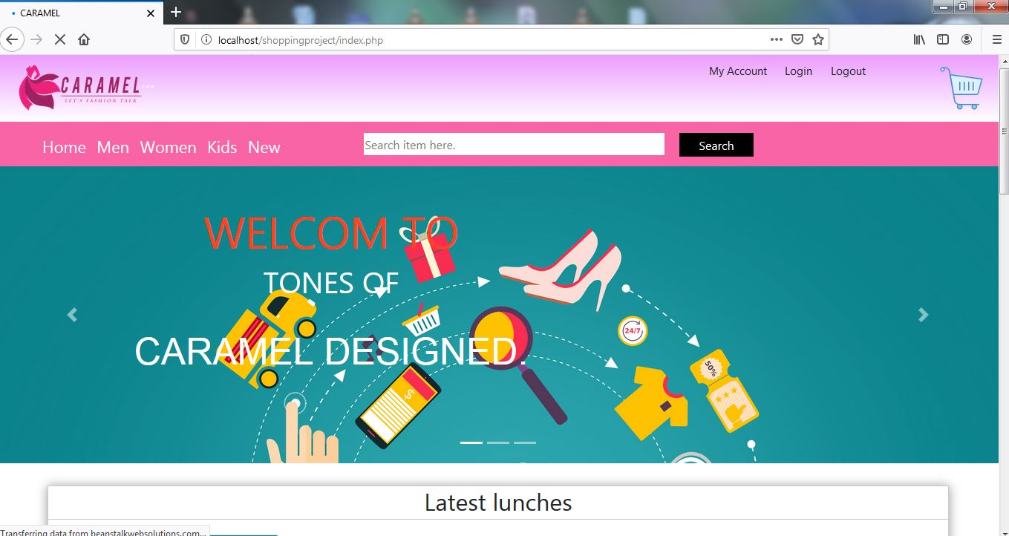

<?php

include 'header.php';

error_reporting(0);

session_start();

ob_start();

?>

<!DOCTYPE html>

<html>

<head>

<title>CARAMEL</title>

<meta name="viewport" content="width=device-width, initial-scale=1.0">

<link rel="stylesheet" type="text/css" href="codes/css/header.css">

<link rel="stylesheet" type="text/css" href="codes/css/slider.css">

<link rel="stylesheet" type="text/css" href="codes/css/footer.css">

<link rel="stylesheet" type="text/css" href="codes/css/saler-body.css">

<!-- Global styles START -->

<script type="text/javascript" src="..\shoppingproject\codes\java script\jquery-3.4.0.min.js"></script>

<script src="https://maxcdn.bootstrapcdn.com/bootstrap/4.0.0/js/bootstrap.min.js" integrity="sha384-JZR6Spejh4U02d8jOt6vLEHfe/JQGiRRSQQxSfFWpi1MquVdAyjUar5+76PVCmYl" crossorigin="anonymous"></script>

<link rel="stylesheet" href="https://maxcdn.bootstrapcdn.com/bootstrap/4.0.0/css/bootstrap.min.css" integrity="sha384-Gn5384xqQ1aoWXA+058RXPxPg6fy4IWvTNh0E263XmFcJlSAwiGgFAW/dAiS6JXm" crossorigin="anonymous">

</head>

<body>

<?php

if($session==true){

header('location:index.php');

}

?>

<!-- ----------------------SLIDER------------------------------- -->

<!-- END SLIDER -->

<!-- <div class="bg-img">

<div id="blk-fg"></div>

<img src="../shopping project/image folder/shopgg.jpg">

</div> -->

<div class="slider-text">

<div class="box-1">

<div id="up-box1">

<h1>WELCOM TO</h1>

</div>

<div id="up-box2"><h1>TONES OF</h1></div>

</div>

<div class="box-2"><h2>CARAMEL DESIGNED.</h2></div>

</div>

<!-- ---------------------------------------------------------------------------

------------------------------Ad Slider------------------------------------ -->

<div id="carouselExampleIndicators" class="carousel slide" data-ride="carousel">

<ol class="carousel-indicators">

<li data-target="#carouselExampleIndicators" data-slide-to="0" class="active"></li>

<li data-target="#carouselExampleIndicators" data-slide-to="1"></li>

<li data-target="#carouselExampleIndicators" data-slide-to="2"></li>

</ol>

<div class="carousel-inner">

<div class="carousel-item active">

<img class="d-block w-100" src="..\shoppingproject\image folder\ways-your-website-can-hurt-sales.jpg" alt="First slide">

</div>

<div class="carousel-item">

<img class="d-block w-100" src="..\shoppingproject\image folder\shopping-images-140625-6934578.jpg" alt="Second slide">

</div>

<div class="carousel-item">

<img class="d-block w-100" src="https://beanstalkwebsolutions.com/blog/wp-content/uploads/2016/08/ways-your-website-can-hurt-sales.jpg" alt="Third slide">

</div>

</div>

<a class="carousel-control-prev" href="#carouselExampleIndicators" role="button" data-slide="prev">

<span class="carousel-control-prev-icon" aria-hidden="true"></span>

<span class="sr-only">Previous</span>

</a>

<a class="carousel-control-next" href="#carouselExampleIndicators" role="button" data-slide="next">

<span class="carousel-control-next-icon" aria-hidden="true"></span>

<span class="sr-only">Next</span>

</a>

</div>

<script type="text/javascript">

$('.carousel').carousel({

interval: 2000

})

</script>

<!-- -----------------------------------BEST SALLERS------------------------------------- -->

<div class="salerbody">

<div class="headtext"><h2>Latest lunches</h2></div>

<?php

include("codes\DbConnect\dbconnect.php");

// $query = "SELECT * FROM products where dist = '$dist' ORDER BY res_id limit $start_from, $num_per_page";

$query = "SELECT * FROM products WHERE type='latest' limit 4";

$sql = mysqli_query($conn,$query);

$file_path = 'image folder/';

while($row1 = mysqli_fetch_array($sql))

{

$rndm_num = $row1['id'];

$brand = $row1['brand'] ;

$name = $row1['name'] ;

$img= $file_path.$row1['image'];

$price= $row1['price'];

$qty= $row1['qty'];

?>

<div class="card" style="width: 18rem;">

<a href="buyproduct.php?id=<?php echo $rndm_num; ?>&brand=<?php echo $brand; ?>&name=<?php echo $name; ?>">

<img class="card-img-top" src="<?php echo $img; ?>" alt="Card image cap"> </a>

<div class="card-body">

<h5 class="card-title"><?php echo $name; ?></h5>

<p class="card-text">₹ <?php echo $price; ?> /-</p>

</div>

</div>

<?php } ?>

</div>

<!-- -----------------------------------Trending Offers------------------------------------- -->

<div class="salerbody">

<div class="headtext"><h2>Trending offers</h2></div>

<?php

$query2 = "SELECT * FROM products WHERE type='trending' limit 4";

$sql1 = mysqli_query($conn,$query2);

$file_path = 'image folder/';

while($row = mysqli_fetch_array($sql1))

{

$rndm_num = $row['id'];

$brand = $row['brand'] ;

$name = $row['name'] ;

$img= $file_path.$row['image'];

$price= $row['price'];

$qty= $row['qty'];

?>

<div class="card" style="width: 18rem;">

<a href="buyproduct.php?id=<?php echo $rndm_num; ?>&brand=<?php echo $brand; ?>&name=<?php echo $name; ?>">

<img class="card-img-top" src="<?php echo $img; ?>" alt="Card image cap"> </a>

<div class="card-body">

<h5 class="card-title"><?php echo $name; ?></h5>

<p class="card-text">₹ <?php echo $price; ?> /-</p>

</div>

</div>

<?php } ?>

</div>

<!-- ------------------------------Image Card---------------------------- -->

<div class="cardbody">

<?php

$query3 = "SELECT * FROM products ORDER BY name DESC Limit 8";

$sql2 = mysqli_query($conn,$query3);

$file_path = 'image folder/';

while($row = mysqli_fetch_array($sql2))

{

$rndm_num = $row['id'];

$brand = $row['brand'] ;

$name = $row['name'] ;

$img= $file_path.$row['image'];

$price= $row['price'];

$qty= $row['qty'];

?>

<div class="card" style="width: 18rem;">

<a href="buyproduct.php?id=<?php echo $rndm_num; ?>&brand=<?php echo $brand; ?>&name=<?php echo $name; ?>">

<img class="card-img-top" src="<?php echo $img; ?>" alt="Card image cap"> </a>

<div class="card-body">

<h5 class="card-title"><?php echo $name; ?></h5>

<p class="card-text">₹ <?php echo $price; ?> /-</p>

</div>

</div>

<?php } ?>

</div>

<footer class="footer">

<p>© 2020 Copyright: <b>Caramel by Sagar</b></p>

</footer>

</body>

</html>

**Product page**

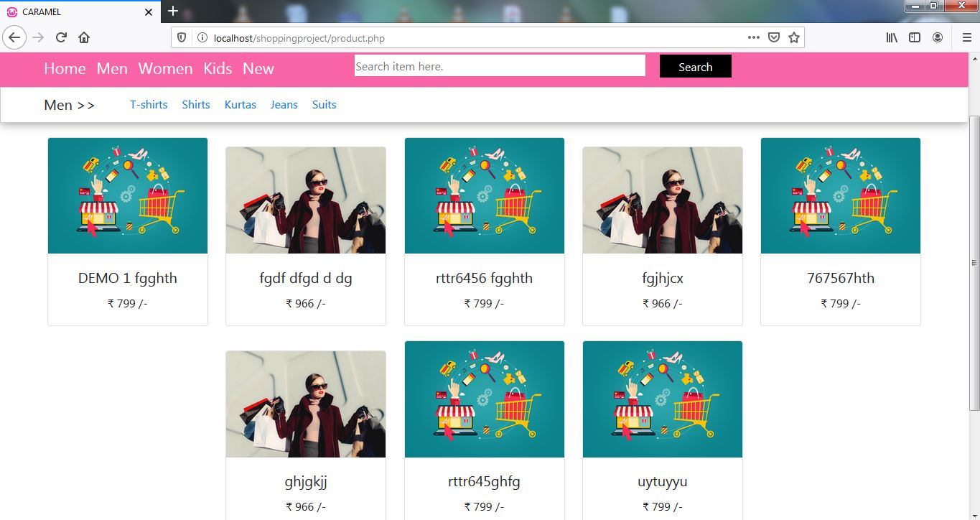

<?php

include("codes\DbConnect\dbconnect.php");

?>

<!DOCTYPE html>

<html>

<head>

<title>CARAMEL</title>

<meta name="viewport" content="width=device-width, initial-scale=1.0">

<link rel="stylesheet" type="text/css" href="codes/css/header.css">

<link rel="stylesheet" type="text/css" href="codes/css/slider.css">

<link rel="stylesheet" type="text/css" href="codes/css/footer.css">

<link rel="stylesheet" type="text/css" href="codes/css/product.css">

<link rel="stylesheet" type="text/css" href="codes/css/saler-body.css">

<!-- Global styles START -->

<script type="text/javascript" src="..\shopping project\codes\java script\jquery-3.4.0.min.js"></script>

<script src="https://maxcdn.bootstrapcdn.com/bootstrap/4.0.0/js/bootstrap.min.js" integrity="sha384-JZR6Spejh4U02d8jOt6vLEHfe/JQGiRRSQQxSfFWpi1MquVdAyjUar5+76PVCmYl" crossorigin="anonymous"></script>

<link rel="stylesheet" href="https://maxcdn.bootstrapcdn.com/bootstrap/4.0.0/css/bootstrap.min.css" integrity="sha384-Gn5384xqQ1aoWXA+058RXPxPg6fy4IWvTNh0E263XmFcJlSAwiGgFAW/dAiS6JXm" crossorigin="anonymous">

</head>

<body>

<!-- ----------------Header------------------ -->

<?php

include 'header.php';

?>

</div>

<!-- ---------------------------------------------------------------------

-----------------------Body Content--------------------------------- -->

<div class="cat-bar">

<h5>Men >> </h5>

<ul>

<li><a href="">T-shirts</a>

<li><a href="">Shirts</a>

<li><a href="">Kurtas</a>

<li><a href="">Jeans</a>

<li><a href="">Suits</a>

</ul>

</div>

<!-- ----------------------------------Content-------------------------

-->

<div class="item-box">

<?php

include("codes\DbConnect\dbconnect.php");

// if (isset($_GET['pageno'])) {

// $page = $_GET['pageno'];

// } else {

// $page = 1;

// }

// $num_per_page = 8;

// $start_from =($page-1)*8;

// $query = "SELECT * FROM products where dist = '$dist' ORDER BY res_id limit $start_from, $num_per_page";

$query = "SELECT * FROM products";

$sql = mysqli_query($conn,$query);

$file_path = 'image folder/';

while($row = mysqli_fetch_array($sql))

{

$rndm_num = $row['id'];

$brand = $row['brand'] ;

$name = $row['name'] ;

$img= $file_path.$row['image'];

$price= $row['price'];

$qty= $row['qty'];

?>

<div class="card" style="width: 14rem;">

<a href="buyproduct.php?id=<?php echo $rndm_num; ?>&brand=<?php echo $brand; ?>&name=<?php echo $name; ?>">

<img class="card-img-top" src="<?php echo $img; ?>" alt="Card image cap"> </a>

<div class="card-body">

<h5 class="card-title"><?php echo $name; ?></h5>

<p class="card-text">₹ <?php echo $price; ?> /-</p>

</div>

</div>

<?php } ?>

</div>

<footer class="footer">

<p>© 2020 Copyright: <b>Caramel by Sagar</b></p>

</footer>

</body>

</html>

**Product specifications**

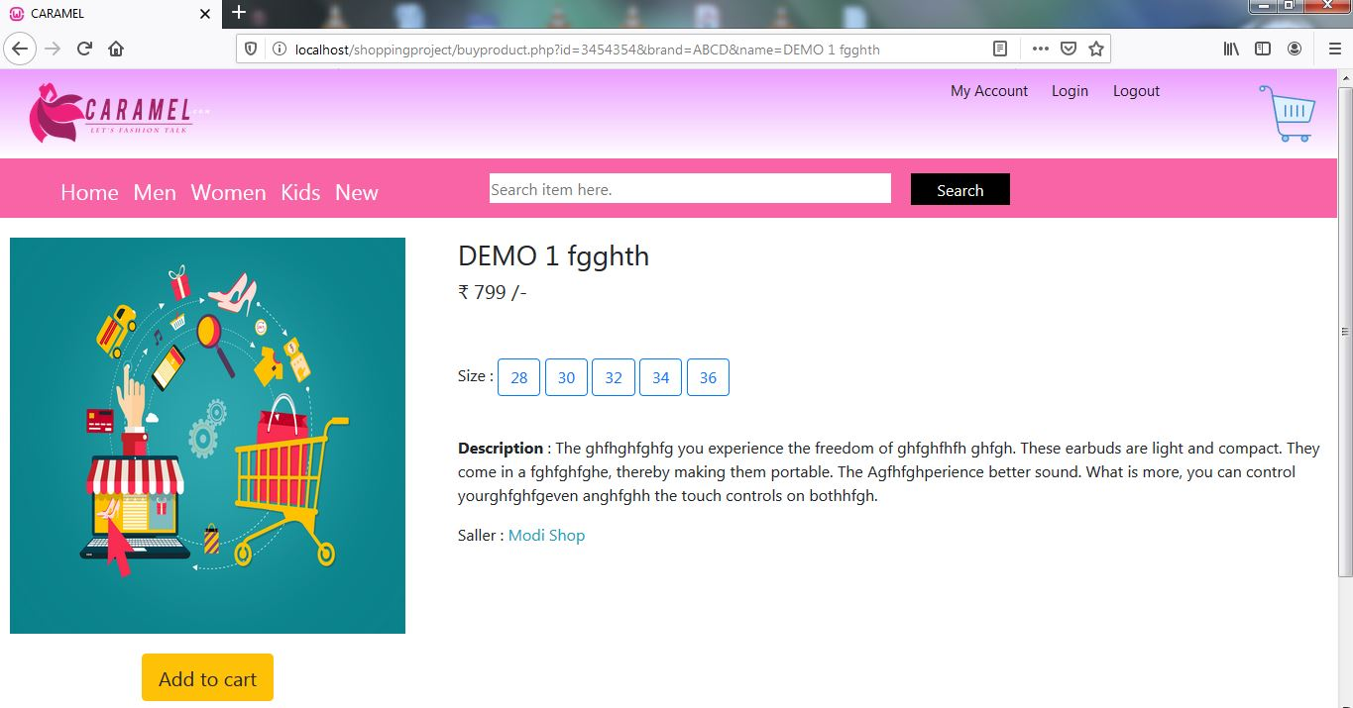

<?php

include("codes\DbConnect\dbconnect.php");

session_start();

$check = $_GET['id'];

$query = "SELECT * FROM products where id='$check'";

$sql = mysqli_query($conn,$query);

$file_path = 'image folder/';

while($row = mysqli_fetch_array($sql))

{

$rndm_num = $row['id'];

$brand = $row['brand'] ;

$name = $row['name'] ;

$img= $file_path.$row['image'];

$price= $row['price'];

$qty= $row['qty'];

$description = $row['description'];

}

?>

<!DOCTYPE html>

<html>

<head>

<title>CARAMEL</title>

<meta name="viewport" content="width=device-width, initial-scale=1.0">

<link rel="stylesheet" type="text/css" href="codes/css/header.css">

<link rel="stylesheet" type="text/css" href="codes/css/slider.css">

<link rel="stylesheet" type="text/css" href="codes/css/footer.css">

<link rel="stylesheet" type="text/css" href="codes/css/buyproduct.css">

<link rel="stylesheet" type="text/css" href="codes/css/saler-body.css">

<!-- Global styles START -->

<script type="text/javascript" src="..\shopping project\codes\java script\jquery-3.4.0.min.js"></script>

<script src="https://maxcdn.bootstrapcdn.com/bootstrap/4.0.0/js/bootstrap.min.js" integrity="sha384-JZR6Spejh4U02d8jOt6vLEHfe/JQGiRRSQQxSfFWpi1MquVdAyjUar5+76PVCmYl" crossorigin="anonymous"></script>

<link rel="stylesheet" href="https://maxcdn.bootstrapcdn.com/bootstrap/4.0.0/css/bootstrap.min.css" integrity="sha384-Gn5384xqQ1aoWXA+058RXPxPg6fy4IWvTNh0E263XmFcJlSAwiGgFAW/dAiS6JXm" crossorigin="anonymous">

</head>

<body>

<!-- ----------------Header------------------ -->

<?php

include 'header.php';

?>

<!-- -----------------------------Product View----------------------------------

------------------------------------------------------------------------------ -->

<div class="body-container">

<div class="image-view"><img src="<?php echo $img; ?>">

<div class="btn-div" style="margin-top: 20px;">

<form action="cart.php?id=<?php echo $check; ?>&action=add" method="POST">

<input type="hidden" name="hidden_id" value="<?php echo $rndm_num; ?>">

<input type="hidden" name="hidden_name" value="<?php echo $name; ?>">

<input type="hidden" name="hidden_price" value="<?php echo $price; ?>">

<input type="hidden" name="hidden_image" value="<?php echo $img; ?>">

<input type="hidden" name="hidden_desc" value="<?php echo $description; ?>">

<input type="submit" name="add_to_cart" value="Add to cart" id="add" class="btn btn-warning btn-lg ">

<!-- <a href="cart.php" class="btn btn-warning btn-lg"><font color=#222>BUY NOW</font></a> -->

</form>

</div>

</div>

<div class="pro-detls">

<h3><?php echo $name; ?></h3>

<h5>₹ <?php echo $price; ?> /-</h5><br><br>

<p>Size :

<input type="button" class="btn btn-outline-primary" value="28">

<input type="button" class="btn btn-outline-primary" value="30">

<input type="button" class="btn btn-outline-primary" value="32">

<input type="button" class="btn btn-outline-primary" value="34">

<input type="button" class="btn btn-outline-primary" value="36">

</p>

<br>

<p><b>Description</b> : <?php echo $description; ?></p>

<p>Saller : <a href="" class="text-info"> Modi Shop</a></p>

</div>

</div>

<footer class="footer">

<p>© 2020 Copyright: <b>Caramel by Sagar</b></p>

</footer>

</body>

</html>

**Cart**

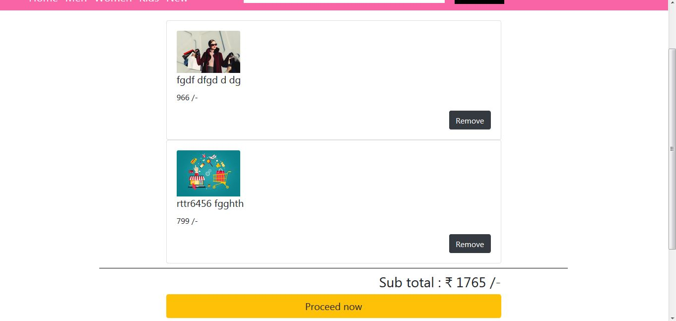

<?php

error_reporting(0);

session_start();

if (isset($_POST['add_to_cart'])) {

if (isset($_SESSION["shopping_cart"])) {

$item_array= array_column($_SESSION["shopping_cart"], "item_id");

if (!in_array($_GET["id"], $item_array)) {

$count = count($_SESSION["shopping_cart"]);

$item_array = array(

'item_id' => $_GET['id'],

'item_code' => $_POST['hidden_id'],

'item_name' => $_POST['hidden_name'],

'item_price' => $_POST['hidden_price'],

'item_desc' => $_POST['hidden_desc'],

'item_image' => $_POST['hidden_image'] );

$_SESSION["shopping_cart"][$count] = $item_array;

}

else{

echo "ITEM ALREADY ADDED";

}

}

else{

$item_array = array(

'item_id' => $_GET['id'],

'item_code' => $_POST['hidden_id'],

'item_name' => $_POST['hidden_name'],

'item_price' => $_POST['hidden_price'],

'item_desc' => $_POST['hidden_desc'],

'item_image' => $_POST['hidden_image'] );

$_SESSION["shopping_cart"][0]=$item_array;

}

}

?>

<!DOCTYPE html>

<html>

<head>

<title>CARAMEL</title>

<meta name="viewport" content="width=device-width, initial-scale=1.0">

<link rel="stylesheet" type="text/css" href="codes/css/header.css">

<link rel="stylesheet" type="text/css" href="codes/css/slider.css">

<link rel="stylesheet" type="text/css" href="codes/css/footer.css">

<link rel="stylesheet" type="text/css" href="codes/css/product.css">

<link rel="stylesheet" type="text/css" href="codes/css/saler-body.css">

<!-- Global styles START -->

<script type="text/javascript" src="..\shoppingproject\codes\java script\jquery-3.4.0.min.js"></script>

<script src="https://maxcdn.bootstrapcdn.com/bootstrap/4.0.0/js/bootstrap.min.js" integrity="sha384-JZR6Spejh4U02d8jOt6vLEHfe/JQGiRRSQQxSfFWpi1MquVdAyjUar5+76PVCmYl" crossorigin="anonymous"></script>

<link rel="stylesheet" href="https://maxcdn.bootstrapcdn.com/bootstrap/4.0.0/css/bootstrap.min.css" integrity="sha384-Gn5384xqQ1aoWXA+058RXPxPg6fy4IWvTNh0E263XmFcJlSAwiGgFAW/dAiS6JXm" crossorigin="anonymous">

<?php

include 'header.php';

$total = 0;

?>

<div class="item" style="padding-top: 20px;">

<?php

foreach($_SESSION["shopping_cart"] as $key => $values) {

$total += (int)$values["item_price"];

?>

<div class="card w-50" style="position: relative; left: 50%; transform: translateX(-50%);">

<div class="card-body"><img class="card-img-top" style="width: 8rem;" src="<?php echo $values["item_image"]; ?>">

<h5 class="card-title"><?php echo $values["item_name"]; ?></h5>

<p class="card-text"><?php echo $values["item_price"];?> /-</p>

<a href="removeitem.php?id=<?php echo $values["item_id"]; ?>" style="float: right;" class="btn btn-dark">Remove</a>

</div>

</div>

<?php } ?>

<div class="underline" style="width: 70%; height: 10px; border-bottom: 1px solid #000; position: relative; left: 50%; transform: translateX(-50%);"></div>

<div class="text" style="width: 50%; height: 120px; margin-top: 10px; position: relative; left: 50%; transform: translateX(-50%);"><h3 style="float: right;">Sub total : ₹ <?php echo $total ?> /-</h3>

<button type="button" class="btn btn-warning btn-lg btn-block">Proceed now</button>

<a href="product.php" class="btn btn-secondary btn-lg btn-block">Add more products</a>

</div>

</div>

<footer class="footer">

<p>© 2020 Copyright: <b>Caramel by Sagar</b></p>

</footer>

</body>

</html>

**CSS**

.body-container{

margin-top: 10px;

width: 100%;

height: auto;

padding: 10px;

}

.image-view{

display: inline-block;

width: 30%;

height: 400px;

}

.image-view img{

width: 100%;

height: 100%;

}

.btn-div{

text-align: center;

width: 100%;

height: 100px;

}

.btn-div button{

margin-top: 25px;

}

.pro-detls{

width: 66%;

height: 400px;

float: right;

}

.footer{

width: 100%;

height: 70px;

background: #222222;

margin-top: 100px;

}

.footer p{

color: white;

text-align: center;

padding-top: 24px;

}

.upper-foot{

width: 100%;

height: 70%;

background: #222222;

border-bottom: 1px solid #666;

}

body{

padding: 0;

margin: 0;

}

.header{

width: 100%;

height: 150px;

background: #000;

}

.header .logo-bar{

width: 100%;

height: 90px;

background-image: linear-gradient(#EB9CFF, #FFFFFF);

}

.header .logo-bar img{

margin-left: 20PX;

position: absolute;

width: 200px;

height: auto;

}

#cart{

width: 100%;

height: 100%;

}

#cart img{

position: absolute;

right: 0;

width: 60px;

height: 60px;

margin: 15px 20px;

transition: .5s;

}

#cart img:hover{

transform: scale(1.2);

}

.navbar{

width: 100%;

position: relative;

height: 60px;

background-color: #F964A6;

padding: 0;

}

.navbar ul{

margin: 0;

}

.navbar ul a{

position: relative;

padding-right:5px;

padding-left: 5px;

margin-top: 5px;

display: inline-block;

text-decoration: none;

list-style: none;

color: #fff;

font-size: 22px;

font-family: segoe UI;

transition: .5s ease;

}

.navbar ul a:hover{

background-color: #000;

color: #fff;

}

.navbar input[type=text]{

display: inline-block;

margin: 15px 0px;

position: absolute;

right: 0;

margin-right: 450px;

top: 0;

width: 30%;

height: 30px;

border-style: none;

font-family: segoe UI;

}

.navbar button{

position: absolute;

top: 0;

right: 0;

margin: 15px 330px;

font-family: segoe UI;

width: 100px;

height: 32px;

background-color: black;

color: white;

border-style: none;

cursor: pointer;

}

.cat-bar{

width: 100%;

height: 50px;

border: 1px solid #ccc;

-webkit-box-shadow: 0px 1px 14px 0px rgba(46,46,46,0.51);

-moz-box-shadow: 0px 1px 14px 0px rgba(46,46,46,0.51);

box-shadow: 0px 1px 14px 0px rgba(46,46,46,0.51);

}

.cat-bar h5{

position: absolute;

padding: 10px 60px;

}

.cat-bar ul{

padding-left: 170px;

}

.cat-bar ul li{

display: inline-block;

padding: 10px;

}

.cat-bar ul li a{

text-decoration: none;

list-style: none;

}

.item-box{

width: 100%;

height: auto;

padding-left: 20px;

padding-top: 20px;

text-align: center;

}

.item-box .card{

display: inline-block;

margin-bottom: 20px;

margin-right: 20px;

}

.salerbody{

position: relative;

left: 50%;

transform: translateX(-50%);

width: 90%;

height: auto;

margin-top: 30px;

text-align: center;

border: 1px solid #ccc;

padding-bottom: 20px;

-webkit-box-shadow: 0px 1px 14px 0px rgba(46,46,46,0.51);

-moz-box-shadow: 0px 1px 14px 0px rgba(46,46,46,0.51);

box-shadow: 0px 1px 14px 0px rgba(46,46,46,0.51);

}

.cardbody{

position: relative;

left: 50%;

transform: translateX(-50%);

width: 90%;

height: auto;

margin-top: 30px;

text-align: center;

}

.salerbody .card{

display: inline-block;

}

.cardbody .card{

display: inline-block;

}

.headtext{

width: 100%;

height: 45px;

border-bottom: 1px solid #ccc;

margin-bottom: 20px;

}

.bg-img{

width: 100%;

height: 600px;

overflow-y: hidden;

}

.bg-img img{

margin-top: -260px;

width: 100%;

height: auto;

}

.bg-img #blk-fg{

background: #000;

width: 100%;

height:600px;

position: absolute;

opacity: .5;

}

.blnk{

width: 100%;

height: 400px;

background: #fff;

}

.try-slider{

width: 100%;

height: 300px;

}

.upper-links{

width: 300px;

height: 50px;

position: absolute;

top: 0;

right: 0;

margin: 0px 100px;

}

.upper-links a{

padding: 10px 10px;

display: inline-block;

color: #1a1a1a;

text-decoration: none;

font-size: 15px;

}

@keyframes rightFedIn{

0%{position: absolute; left: -80px; opacity: 0;}

100%{position: absolute; left: 0px; opacity: 1;}

}

.slider-text{

width: 700px;

height: 350px;

position: absolute;

top: 0;

margin : 200px 100px;

text-align: center;

animation-name: rightFedIn;

animation-duration: 4s;

z-index: 1;

}

.slider-text .box-1{

width: 100%;

height: 50%;

}

.slider-text .box-1 #up-box1{

width: 100%;

height: 40%;

text-align: center;

}

.slider-text .box-1 #up-box1 h1{

color: #FF4220;

font-size: 60px;

}

.slider-text .box-1 #up-box2{

width: 100%;

height: 50%;

text-align: center;

}

.slider-text .box-1 #up-box2 h1{

color: white;

font-size: 40px;

margin-top: 10px;

}

.slider-text .box-2{

width: 100%;

height: 50%;

}

.slider-text .box-2 h2{

color: white;

font-family: sans-serif;

font-size: 50px;

margin-top: -5px;

}

.carouselbox{

position: absolute;

border:4px solid blue;

width: 100%;

height: 300px;

}

#carouselExampleIndicators{

width: 100%;

height: 400px;

overflow-y: hidden;

}

.carousel-item img{

width: 100%;

}